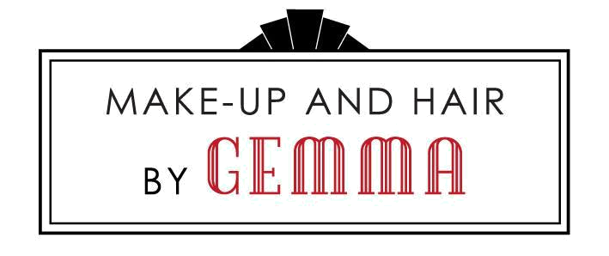
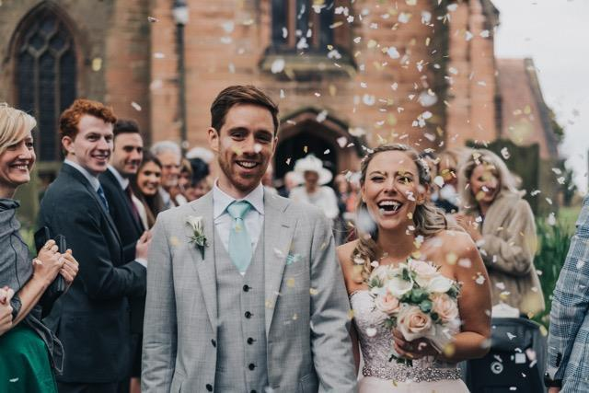

Bridal Booking Form
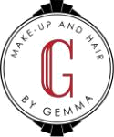

About Your Day

Full Name

New Surname Age Address

Telephone Number

Postcode

Mobile Number

Email Address

Date of Wedding

Time of Ceremony

Address of Preparation (if different from above)

Postcode

Place of Ceremony

Estimated Travel Time

Wedding Theme / Colour Scheme

Colour / Style of Dress (please bring picture to all trials)

Style of Head Dress (please bring to all trials)

Description of Flowers

Photographer Name & Address

Postcode

Will the photographer be present for the bride’s preparation? Yes ☐ No ☐

Make-Up and Hair by Gemma. Salon G, 82 Three Shires Oak Road, Bearwood, Birmingham, B67 5BY

- 07961 828860 W: www.make-upandhairbygemma.co.uk E: info@make-upandhairbygemma.co.uk
 Facebook.com/Makeupandhairbygemma Instagram.com/makeupandhairbygemma

About You

Eye Colour

Contact Lenses / Spectacles Wearer Yes ☐ No ☐

Face Shape

Round ☐ Oval ☐ Heart ☐ Long ☐ Square ☐ Other ☐

Skin Tone

Combination ☐ Oily ☐ Oily T-Zone Dry Cheeks

☐ Other ☐

Skin Colour

Pale ☐ Fair (freckles) ☐ Olive ☐ Tanned ☐ Asian ☐ Oriental ☐ Black ☐

Do you suffer from any allergies / conditions / reactions to cosmetics?

Hair Colour

Length

Natural Style

Desired Bride Style (attach picture if possible)

Make-Up and Hair by Gemma. Salon G, 82 Three Shires Oak Road, Bearwood, Birmingham, B67 5BY

- 07961 828860 W: www.make-upandhairbygemma.co.uk E: info@make-upandhairbygemma.co.uk
Facebook.com/Makeupandhairbygemma Instagram.com/makeupandhairbygemma

Cost of Bridal Styling

No. Required

Cost

Bride’s Make-up (inc. 1 trial)

£

Bride’s Hair Styling (inc. 1 trial)

£

Adult Bridesmaid’s Make-up

£

Adult Bridesmaid’s Hair Styling

£

Child Bridesmaid’s Hair Styling

£

Mother of the Bride Make-up

£

Mother of the Bride Hair Styling

£

Guest Make-up

£

Guest Hair Styling

£

Total Travel (miles)

£

Extras

£

Less non-refundable deposit paid at booking

£

Total Due

£

Preferred Date of First Trial

(to take place at Salon G unless otherwise agreed)

To confirm your booking, please complete this form as fully as possible and enclose your non-refundable deposit cheque for £100 (made payable to Gemma Howard-Masters).

Signature

Name

Date

Please note:

Part or full payment at the trial and the remaining balance on the day, cash or cheque.

Make-Up and Hair by Gemma. Salon G, 82 Three Shires Oak Road, Bearwood, Birmingham, B67 5BY

- 07961 828860 W: www.make-upandhairbygemma.co.uk E: info@make-upandhairbygemma.co.uk
Facebook.com/Makeupandhairbygemma Instagram.com/makeupandhairbygemma

